MWTGNBOP-5558
NBOP - TMO - Usage Inquiry update

Step 1: Log in to NBOP application and search for an existing Phone, Tablet or Smartwatch TMO lines so that we can able to see line-summary screen.
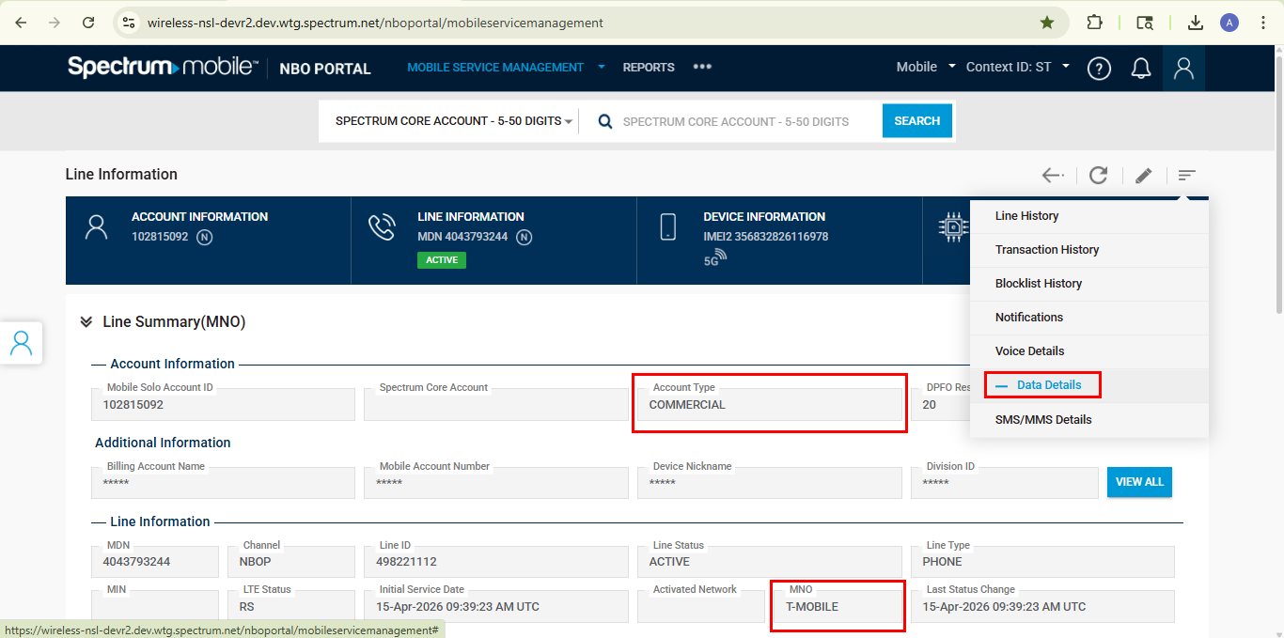
Step 2: Click on the Data Details menu, so that the page will navigate to Data Details Screen. Ensure the cards and parameters are not visible according to the TMO requirements.
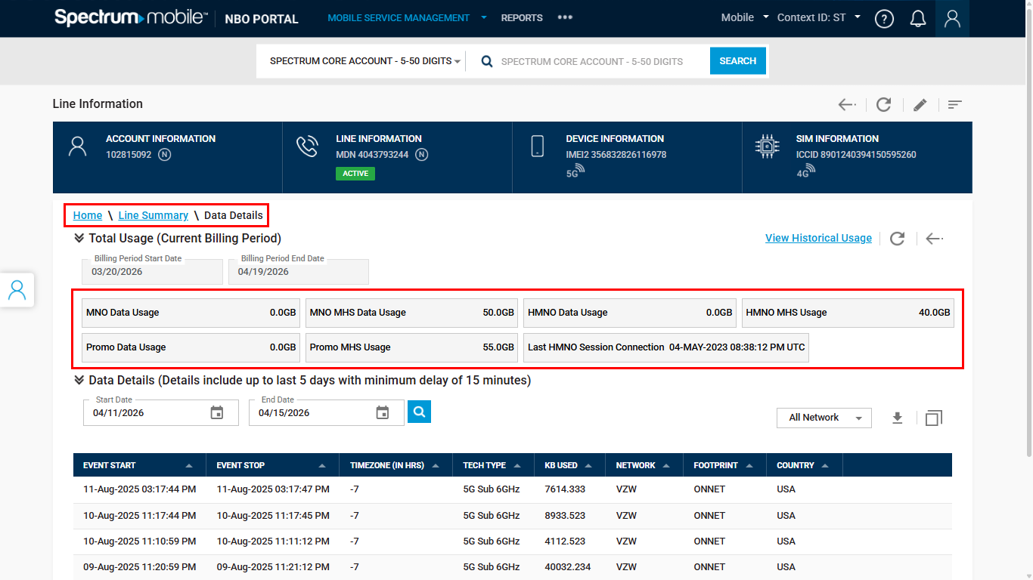
Step 3: Click on the View Historical Usage, so that the page will navigate to Historical Usage Grid. Ensure the cards and parameters are not visible according to the TMO requirements.
